

<<DATA>>

<<EMPRESA>>

<<RESPONSAVEL_GERAL>>

<<DASHBOARD>>

<<NUMERO>> | <<SETOR>>  <<ADEQUACAO_NC>>  Comentários:  <<COMENTARIO>> | <<ADEQUACAO>> |  | <<DATA_ITEM>> | <<RESPONSAVEL_ITEM>>

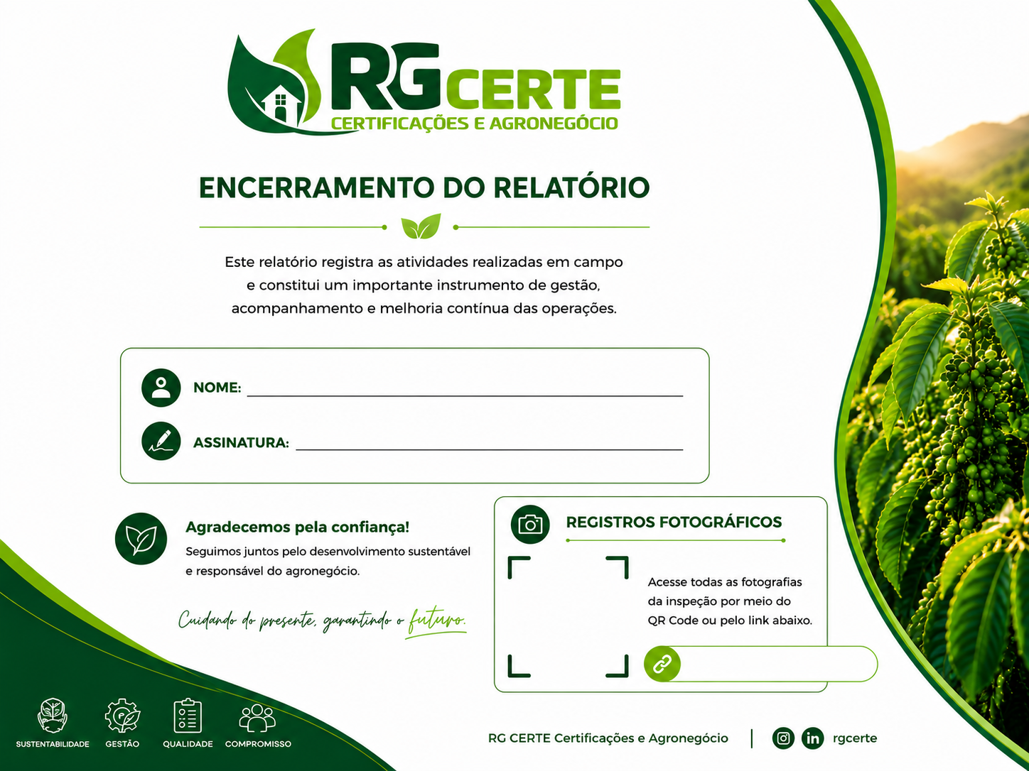
<< FOTOS>>

<<RESPONSAVEL_GERAL>>

<<QRCODE>>

